**C128 Diagnostic – Keyboard PCB Rev. 1/SMD**

**Module Description**

# Introduction

This is the keyboard Dongle (PCB) for the Commodore C128 Diagnostic Rev. 588121. The required harness is identical to the C64 Diagnostic Rev. 586220 harness, except the keyboard PCB. The C64 harness can be found here:

<https://github.com/svenpetersen1965/C64-Diagnostic-Rev.-586220-Harness>

A part of the keyboard scan lines are shared with the control ports. To prevent a false “OK” while testing these, the feedbacks can be opened. The required analog switches are implemented on the user port PCB (Rev. 1) of the said C64 harness. The connection to the user port PCB is provided by a ribbon cable, which can be connected to the box pin header J3.

In case this feature is not desired or the user port PCB is of an earlier revision, the adjacent pins of J3 can be jumpered with standard jumpers (1-2, 3-4, 5-6, 7-8 and 9-10).

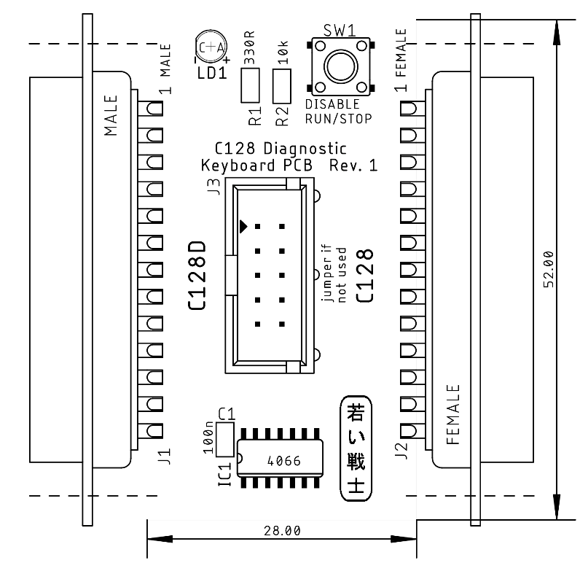

Figure 1: Dimensions of the C128 Diagnostic Keyboard PCB

The footprint of the keyboard connector on the C128 mainboard is for a 90° female DSub-25 connector (for the C128D). A special pin header is populated on the mainboard. It fits a female DSub-25 connector (J2). The pin numbering is in the opposite direction of a normal male DSub-25, though. This results in a discrepancy of the pin numbering of J2, which is correct.

The regular feedbacks are COL0 to ROW0, COL1 to ROW1, … COL7 to ROW7.

The feedback COL7 to ROW7 mimics a RUN/STOP while power up. This causes the C128 to boot into the monitor program, which is not desired. This can be circumvented by pressing the disable button on this PCB. This causes the analog switch (IC1) to open, which is responsible for this feedback.

# Connectors

|  |  |  |
| --- | --- | --- |
| **Signal** | **J1 (C128D)** | **J2 (C128)** |
| GND | 1 | 13 |
| (no pin) | 2 | 12 |
| RESTORE | 3 | 11 |
| +5V | 4 | 10 |
| ROW3 | 5 | 9 |
| ROW6 | 6 | 8 |
| ROW5 | 7 | 7 |
| ROW4 | 8 | 6 |
| ROW7 | 9 | 5 |
| ROW2 | 10 | 4 |
| ROW1 | 11 | 3 |
| ROW0 | 12 | 2 |
| COL0 | 13 | 1 |
| COL6 | 14 | 25 |
| COL5 | 15 | 24 |
| COL4 | 16 | 23 |
| COL3 | 17 | 22 |
| COL2 | 18 | 21 |
| COL1 | 19 | 20 |
| COL7 | 20 | 19 |
| K0 | 21 | 18 |
| K1 | 22 | 17 |
| K2 | 23 | 16 |
| 40/80 | 24 | 15 |
| CAPS LOCK | 25 | 14 |

J3 – box pin header 2x5 circuits

|  |  |  |  |
| --- | --- | --- | --- |
| **Signal** | **Pin** | **Pin** | **Signal** |
| COL4 | 1 | 2 | ROW4 |
| COL3 | 3 | 4 | ROW3 |
| COL2 | 5 | 6 | ROW2 |
| COL1 | 7 | 8 | ROW1 |
| COL0 | 9 | 10 | ROW0 |

# Links

This PCB is designed based on the following information:

* <http://blog.worldofjani.com/?p=164>
* <http://personalpages.tds.net/~rcarlsen/cbm/c128/SCHEMATICS/>
* <https://commons.wikimedia.org/wiki/File:C128mobo.jpg?uselang=de>

# Revision History

## Rev. 0

* Prototype

## Rev. 1

* PCB Revision: board is now 28mm wide

## Rev. 1/SMD

* Board revision
* R, C, IC SMD footprints for easier manufacturing